Plastic Waste Reduction and Awareness Portal

Software Requirements Specification

CS401
Software Engineering

Student Names
Student Registration Numbers

Prepared for
Continuous Assessment 3
Spring 2025

Table of Contents
1. Introduction
1.1 Purpose
1.2 Scope
1.3 Definitions, Acronyms, and Abbreviations
1.4 References
1.5 Overview

2. General Description
2.1 Product Perspective
2.2 Product Functions
2.3 User Characteristics
2.4 General Constraints
2.5 Assumptions and Dependencies

3. Specific Requirements
3.1 External Interface Requirements
3.1.1 User Interfaces
3.1.2 Hardware Interfaces
3.1.3 Software Interfaces
3.1.4 Communications Interfaces
3.2 Functional Requirements
3.2.1 User Registration and Authentication
3.2.2 Admin Validation and Management
3.2.3 Content and Campaign Management
3.2.4 Resource Filtering and Discovery
3.2.5 Recycling Point Locator
3.2.6 Notification System
3.2.7 Reporting and Analytics
3.5 Non-Functional Requirements
3.5.1 Performance
3.5.2 Reliability
3.5.3 Availability
3.5.4 Security
3.5.5 Maintainability
3.5.6 Portability
3.7 Design Constraints
3.9 Other Requirements

4. Analysis Models
4.1 Data Flow Diagrams (DFD)
4.1.1 Level 0 DFD (Context Diagram)
4.1.2 Level 1 DFD (System Processes)

5. Github Link
6. Deployed Link

A. Appendices
A.1 Appendix 1 – Use Case Diagrams
A.2 Appendix 2 – Entity Relationship Diagram (ERD)

1. Introduction
This Software Requirements Specification (SRS) document describes the functional and non-functional requirements for the Plastic Waste Reduction and Awareness Portal. This document is intended for software developers, project managers, quality assurance engineers, and stakeholders involved in the design and development of the system. It serves as the primary reference for the development team and the basis for all design and testing activities.

1.1 Purpose
The purpose of this SRS is to provide a detailed and comprehensive description of the Plastic Waste Reduction and Awareness Portal. This document defines the system's intended behavior, constraints, user roles, and technical requirements. It is primarily written for:
- Software developers and engineers responsible for building the platform
- Project managers overseeing development timelines and deliverables
- Quality assurance teams for test planning and validation
- Stakeholders including environmental organizations, recycling agencies, and end-users

1.2 Scope
The Plastic Waste Reduction and Awareness Portal is an online web-based platform designed to combat plastic pollution by bridging consumers, businesses, recycling agencies, and awareness organizations. The system will:
- Allow users to register and access curated plastic waste reduction resources
- Enable administrators to validate and onboard key stakeholders such as recycling agencies and awareness organizations
- Allow proposers (organizations and businesses) to add campaigns, educational content, and eco-friendly solutions
- Provide end-users with filtering capabilities to find recycling points, education programs, and eco-friendly product alternatives
- Raise awareness through targeted campaigns and community engagement features

The portal will NOT include e-commerce transactions, waste collection logistics, or real-time GPS tracking. It serves purely as an informational and community engagement platform.

1.3 Definitions, Acronyms, and Abbreviations

Term / Acronym | Definition
SRS | Software Requirements Specification
Admin | System Administrator responsible for validating organizations
Proposer | Registered entity (organization or business) that adds content to the portal
End-User | General public or consumer who browses and uses portal resources
Recycling Agency | A certified organization that manages recycling points and programs
DFD | Data Flow Diagram
UI | User Interface
API | Application Programming Interface
SSL/TLS | Secure Sockets Layer / Transport Layer Security
DBMS | Database Management System
GDPR | General Data Protection Regulation
MFA | Multi-Factor Authentication

1.4 References
- IEEE Std 830-1998: IEEE Recommended Practice for Software Requirements Specifications
- IEEE Guide to SRS, 2nd Edition
- United Nations Environment Programme (UNEP) Plastic Waste Reports
- GDPR Guidelines for Web Platform Data Handling (2018)
- OWASP Top 10 Web Application Security Risks
- W3C Web Content Accessibility Guidelines (WCAG) 2.1

1.5 Overview
This SRS is organized as follows:
- Section 2 provides a general description of the product, its perspective, functions, user characteristics, constraints, and dependencies
- Section 3 presents the specific requirements including external interface requirements, functional requirements, and non-functional requirements
- Section 4 presents analysis models including Data Flow Diagrams
- Sections 5–11 contain project links, proof documents, and compliance records
- Appendices provide supplementary material

2. General Description
This section describes the general factors that affect the Plastic Waste Reduction and Awareness Portal and its requirements. It provides context for the specific requirements in Section 3.

2.1 Product Perspective
The Plastic Waste Reduction and Awareness Portal is an independently developed web platform that operates as a centralized hub connecting consumers, businesses, recycling agencies, and environmental organizations. The platform does not replace existing waste management systems but complements them by providing awareness, education, and resource discovery tools.
The system interacts with:
- Web browsers via a responsive web interface
- Email servers for user notifications and verification
- Third-party map APIs for displaying recycling point locations
- Cloud storage services for media and document uploads
- Payment or transaction gateways (for optional campaign contribution features)

2.2 Product Functions
The platform will provide the following core functions:
- User Registration and Authentication: Secure registration for all user types (end-users, proposers, admins)
- Admin Validation Dashboard: Admins can review, approve, or reject proposer and agency applications
- Content Management: Proposers can add, edit, and manage campaigns, articles, recycling solutions, and eco-friendly alternatives
- Resource Discovery: End-users can search and filter resources by category (recycling points, education programs, eco-friendly products)
- Campaign Management: Organizations can run awareness campaigns with goals, timelines, and impact metrics
- Recycling Point Locator: An interactive map showing verified recycling locations
- Notification System: Email and in-app notifications for account status, campaign updates, and new resources
- Reporting and Analytics: Admins can view platform usage statistics and campaign impact reports

2.3 User Characteristics
The platform is designed for the following user groups:

User Role | Technical Level | Description
Administrator | High | Platform manager with full access to validate organizations, manage users, and oversee content
Proposer | Medium | Businesses or NGOs who submit and manage campaigns, resources, and solutions
End-User | Low–Medium | General public seeking information on recycling, eco-friendly products, and education programs
Recycling Agency | Medium | Verified organizations providing recycling point data and collection information
Awareness Organization | Medium | NGOs or institutions running plastic awareness campaigns and educational initiatives

2.4 General Constraints
- The platform must comply with GDPR and applicable data privacy regulations
- The system must be accessible on modern browsers (Chrome, Firefox, Safari, Edge — latest 2 versions)
- All content submitted by proposers must be reviewed and approved by admins before going live
- The platform must support at least 3 languages in its initial release (English, regional language support optional)
- The system must operate within budget and timeline constraints of the academic project
- Third-party APIs (map services, email providers) must use free or low-cost tiers within project scope

2.5 Assumptions and Dependencies
The following assumptions and dependencies underpin this SRS:
- It is assumed that users will have reliable internet access and modern web browsers
- The platform depends on a cloud hosting service (e.g., AWS, Heroku, or Render) being available
- It is assumed that recycling agencies and organizations will provide accurate data upon registration
- The email notification system depends on an SMTP service such as SendGrid or Mailgun
- Map-based features depend on a third-party mapping API (e.g., Google Maps or OpenStreetMap)
- Admin moderation is assumed to be performed within 48 hours of a proposer's submission

3. Specific Requirements
This section describes the detailed requirements that guide the design, implementation, and testing of the Plastic Waste Reduction and Awareness Portal. Each requirement is correct, unambiguous, verifiable, prioritized, and uniquely identifiable.

3.1 External Interface Requirements

3.1.1 User Interfaces
- The system shall provide a responsive web interface compatible with desktop, tablet, and mobile devices
- The landing page shall display featured campaigns, recent resources, and a search bar for filtering content
- User dashboards shall be role-specific: end-users see saved resources; proposers see content management tools; admins see validation queues
- The admin panel shall display pending approvals, registered organizations, and platform analytics in a tabular format
- All forms shall provide real-time validation feedback with clear error messages
- The UI shall follow WCAG 2.1 Level AA accessibility standards

3.1.2 Hardware Interfaces
- The system shall run on standard web server hardware (minimum 2-core CPU, 4GB RAM)
- No specialized hardware is required from the user side beyond a device with internet access
- The server shall have at least 50GB of storage for media files, documents, and database records

3.1.3 Software Interfaces
- Backend Framework: Node.js / Django / Laravel (to be finalized during design phase)
- Database: PostgreSQL or MySQL for relational data storage
- Map Integration: Google Maps API or OpenStreetMap for displaying recycling locations
- Email Service: SMTP integration via SendGrid or Mailgun for transactional emails
- Cloud Storage: AWS S3 or Firebase Storage for uploaded media and documents
- Authentication: JWT-based token authentication or OAuth 2.0

3.1.4 Communications Interfaces
- All data transmission shall be encrypted using HTTPS (SSL/TLS)
- The system shall use RESTful APIs for communication between frontend and backend
- Email notifications shall be sent using SMTP protocol
- Real-time notifications may use WebSocket connections for instant alerts

3.2 Functional Requirements
The following functional requirements define specific features of the platform:

3.2.1 User Registration and Authentication

3.2.1.1 Introduction
This feature enables all user types to create accounts and securely access the platform. Users must register with their email and are assigned roles (end-user, proposer, or admin).

3.2.1.2 Inputs
- User email address, password, full name, and role type
- Proposer additional inputs: organization name, registration certificate, contact number

3.2.1.3 Processing
- System validates email uniqueness and password strength
- System sends email verification link upon registration
- Proposer accounts are flagged as pending until admin approval
- Passwords are hashed using bcrypt or equivalent

3.2.1.4 Outputs
- Account creation confirmation email
- User dashboard access upon successful login
- JWT authentication token issued

3.2.1.5 Error Handling
- Duplicate email: display 'Email already registered' error
- Weak password: display password strength requirements
- Unverified email: redirect to verification prompt

3.2.2 Admin Validation and Management

3.2.2.1 Introduction
Administrators review and validate proposers, recycling agencies, and awareness organizations. This ensures only verified entities add content to the platform.

3.2.2.2 Inputs
- Proposer registration request with supporting documents
- Admin login credentials

3.2.2.3 Processing
- Admin views pending proposer/agency applications in a queue
- Admin reviews submitted documents (certificates, registration proofs)
- Admin approves or rejects with optional remarks
- Approved proposers are notified via email and granted content creation access

3.2.2.4 Outputs
- Updated proposer status (Approved/Rejected)
- Email notification sent to proposer
- Audit log entry created for admin action

3.2.2.5 Error Handling
- Missing documents: system flags application as 'Incomplete'
- Invalid document format: display accepted file format requirements

3.2.3 Content and Campaign Management

3.2.3.1 Introduction
Approved proposers can create, edit, and manage content including awareness campaigns, educational articles, and eco-friendly solution listings.

3.2.3.2 Inputs
- Campaign title, description, goals, target audience, start/end dates
- Media files (images, videos, documents)
- Category tags (e.g., recycling, education, eco-alternatives)

3.2.3.3 Processing
- System validates all required fields before submission
- Content is saved as draft until submitted for admin review
- Admin approves content before it becomes publicly visible
- Proposer can edit or delete their own content

3.2.3.4 Outputs
- Draft saved confirmation
- Submission for review confirmation
- Published content visible on the portal

3.2.3.5 Error Handling
- Missing required fields: highlight fields with error indicators
- File size exceeds limit: display maximum file size message
- Unsupported file type: display accepted formats

3.2.4 Resource Filtering and Discovery

3.2.4.1 Introduction
End-users can search and filter the platform's resources by various categories to find relevant content such as recycling points, educational programs, and eco-friendly alternatives.

3.2.4.2 Inputs
- Search keyword(s)
- Filter parameters: category, location, date added, organization type

3.2.4.3 Processing
- System queries the database based on search and filter inputs
- Results are ranked by relevance and recency
- Recycling points display on an interactive map
- Users can save resources to their profile for later reference

3.2.4.4 Outputs
- Filtered list of resources with titles, descriptions, and category tags
- Map pins for recycling location results
- Pagination for large result sets

3.2.4.5 Error Handling
- No results found: display 'No resources match your criteria' with suggestions
- Map API failure: display list view as fallback

3.2.5 Recycling Point Locator

3.2.5.1 Introduction
This feature displays verified recycling points on an interactive map, allowing users to find nearby recycling facilities.

3.2.5.2 Inputs
- User's current location (browser geolocation or manual address input)
- Filter by material type (plastic, glass, paper, etc.)

3.2.5.3 Processing
- System retrieves verified recycling point data from the database
- Map API renders pins at recycling locations
- Clicking a pin displays facility name, address, operating hours, and accepted materials

3.2.5.4 Outputs
- Interactive map with recycling point pins
- Sidebar list view of recycling points sorted by proximity

3.2.5.5 Error Handling
- Location access denied: prompt for manual address entry
- No nearby points: expand search radius and notify user

3.2.6 Notification System

3.2.6.1 Introduction
The system sends automated email and in-app notifications to users for key events such as account approval, content status changes, and new campaigns.

3.2.6.2 Inputs
- System-triggered events (account approved, content published, campaign started)
- User notification preferences

3.2.6.3 Processing
- System generates notification on triggering event
- Notification sent via email and stored in the in-app notification center
- Users can mark notifications as read or configure preferences

3.2.6.4 Outputs
- Email notification delivered to user
- In-app notification badge updated

3.2.6.5 Error Handling
- Email delivery failure: log error and retry up to 3 times
- Notification preference not set: default to all notifications enabled

3.2.7 Reporting and Analytics

3.2.7.1 Introduction
Administrators can access a reporting dashboard to view platform usage statistics, campaign performance, and user engagement metrics.

3.2.7.2 Inputs
- Date range selection for report generation
- Report type (user activity, campaign reach, content engagement)

3.2.7.3 Processing
- System aggregates data from the database based on selected parameters
- Charts and graphs are generated for visual representation
- Reports can be exported in CSV or PDF format

3.2.7.4 Outputs
- Dashboard with charts: user registrations over time, active campaigns, top resources
- Downloadable report files

3.2.7.5 Error Handling
- No data available for selected range: display 'No data available for this period'
- Export failure: display retry option

3.5 Non-Functional Requirements

3.5.1 Performance
- 95% of page load requests shall complete within 3 seconds under normal load (up to 500 concurrent users)
- Search and filter queries shall return results within 2 seconds for datasets up to 10,000 records
- The system shall support at least 1,000 concurrent users during peak campaign launches
- API response time shall not exceed 1 second for standard CRUD operations

3.5.2 Reliability
- The system shall have a Mean Time Between Failures (MTBF) of at least 720 hours (30 days)
- All user data shall be backed up daily with a Recovery Point Objective (RPO) of 24 hours
- The system shall implement automatic failover for critical database operations
- Error logs shall be maintained and monitored continuously for critical failures

3.5.3 Availability
- The platform shall maintain 99.5% uptime, allowing no more than 3.65 hours of downtime per year
- Planned maintenance windows shall be communicated to users at least 24 hours in advance
- The system shall display a maintenance page during scheduled downtime

3.5.4 Security
- All data transmission shall be secured using HTTPS with TLS 1.2 or higher
- User passwords shall be stored using bcrypt hashing with a minimum cost factor of 12
- The system shall implement role-based access control (RBAC) to restrict unauthorized access
- Admin accounts shall require Multi-Factor Authentication (MFA)
- The system shall be protected against OWASP Top 10 vulnerabilities (SQL injection, XSS, CSRF, etc.)
- Session tokens shall expire after 30 minutes of inactivity

3.5.5 Maintainability
- The codebase shall follow MVC (Model-View-Controller) architecture for modularity
- Code shall adhere to documented coding standards with inline comments for all non-trivial functions
- The system shall provide an admin interface for content moderation without requiring code changes
- Database schema changes shall be managed through versioned migration scripts
- All third-party API integrations shall be abstracted through service layers to simplify replacement

3.5.6 Portability
- The frontend shall be compatible with Chrome, Firefox, Safari, and Edge (latest 2 major versions)
- The platform shall be deployable on any major cloud provider (AWS, Azure, Google Cloud, Heroku)
- The application shall be containerized using Docker for consistent deployment across environments
- The system shall be responsive and function on screen sizes from 320px (mobile) to 2560px (large desktop)

3.7 Design Constraints
- The platform must be developed within the academic project timeline of one semester
- Third-party service integrations must use free-tier or open-source alternatives where possible
- The system must not store sensitive personal data beyond what is necessary (data minimization principle)
- The user interface must align with environmental branding (green/eco color scheme) to reinforce the platform mission
- All content displayed publicly must be approved by admin to prevent misinformation

3.9 Other Requirements
- The platform shall comply with applicable environmental data sharing regulations
- The system shall maintain an audit trail of all admin actions for accountability
- The platform shall support content in at least English; additional language support is desirable
- Future versions may include gamification features (badges, leaderboards for eco-actions)
- The platform shall provide a feedback/rating mechanism for recycling locations and campaigns

4. Analysis Models
This section lists the analysis models used to develop the specific requirements of the Plastic Waste Reduction and Awareness Portal. Each model is described with a narrative and is traceable back to the requirements in Section 3.

4.1 Data Flow Diagrams (DFD)

4.1.1 Level 0 DFD (Context Diagram)
The context diagram illustrates the overall system as a single process and shows the external entities that interact with it. The Plastic Waste Reduction and Awareness Portal receives inputs from End-Users, Proposers/Organizations, and Administrators, and outputs information, notifications, and validated content to each respective entity. External systems include the Email Server, Map API, and Cloud Storage Service.

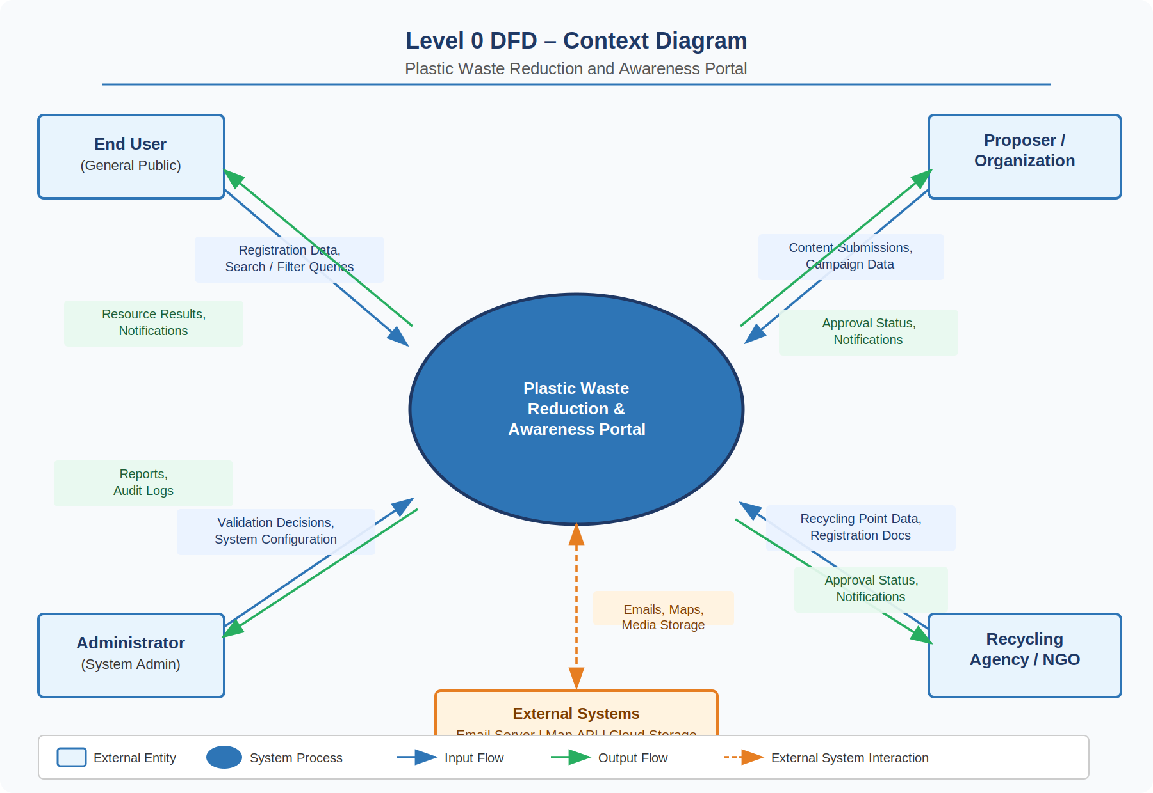
Figure 4.1 – Level 0 DFD (Context Diagram)

4.1.2 Level 1 DFD (System Processes)
The Level 1 DFD decomposes the system into its core processes:
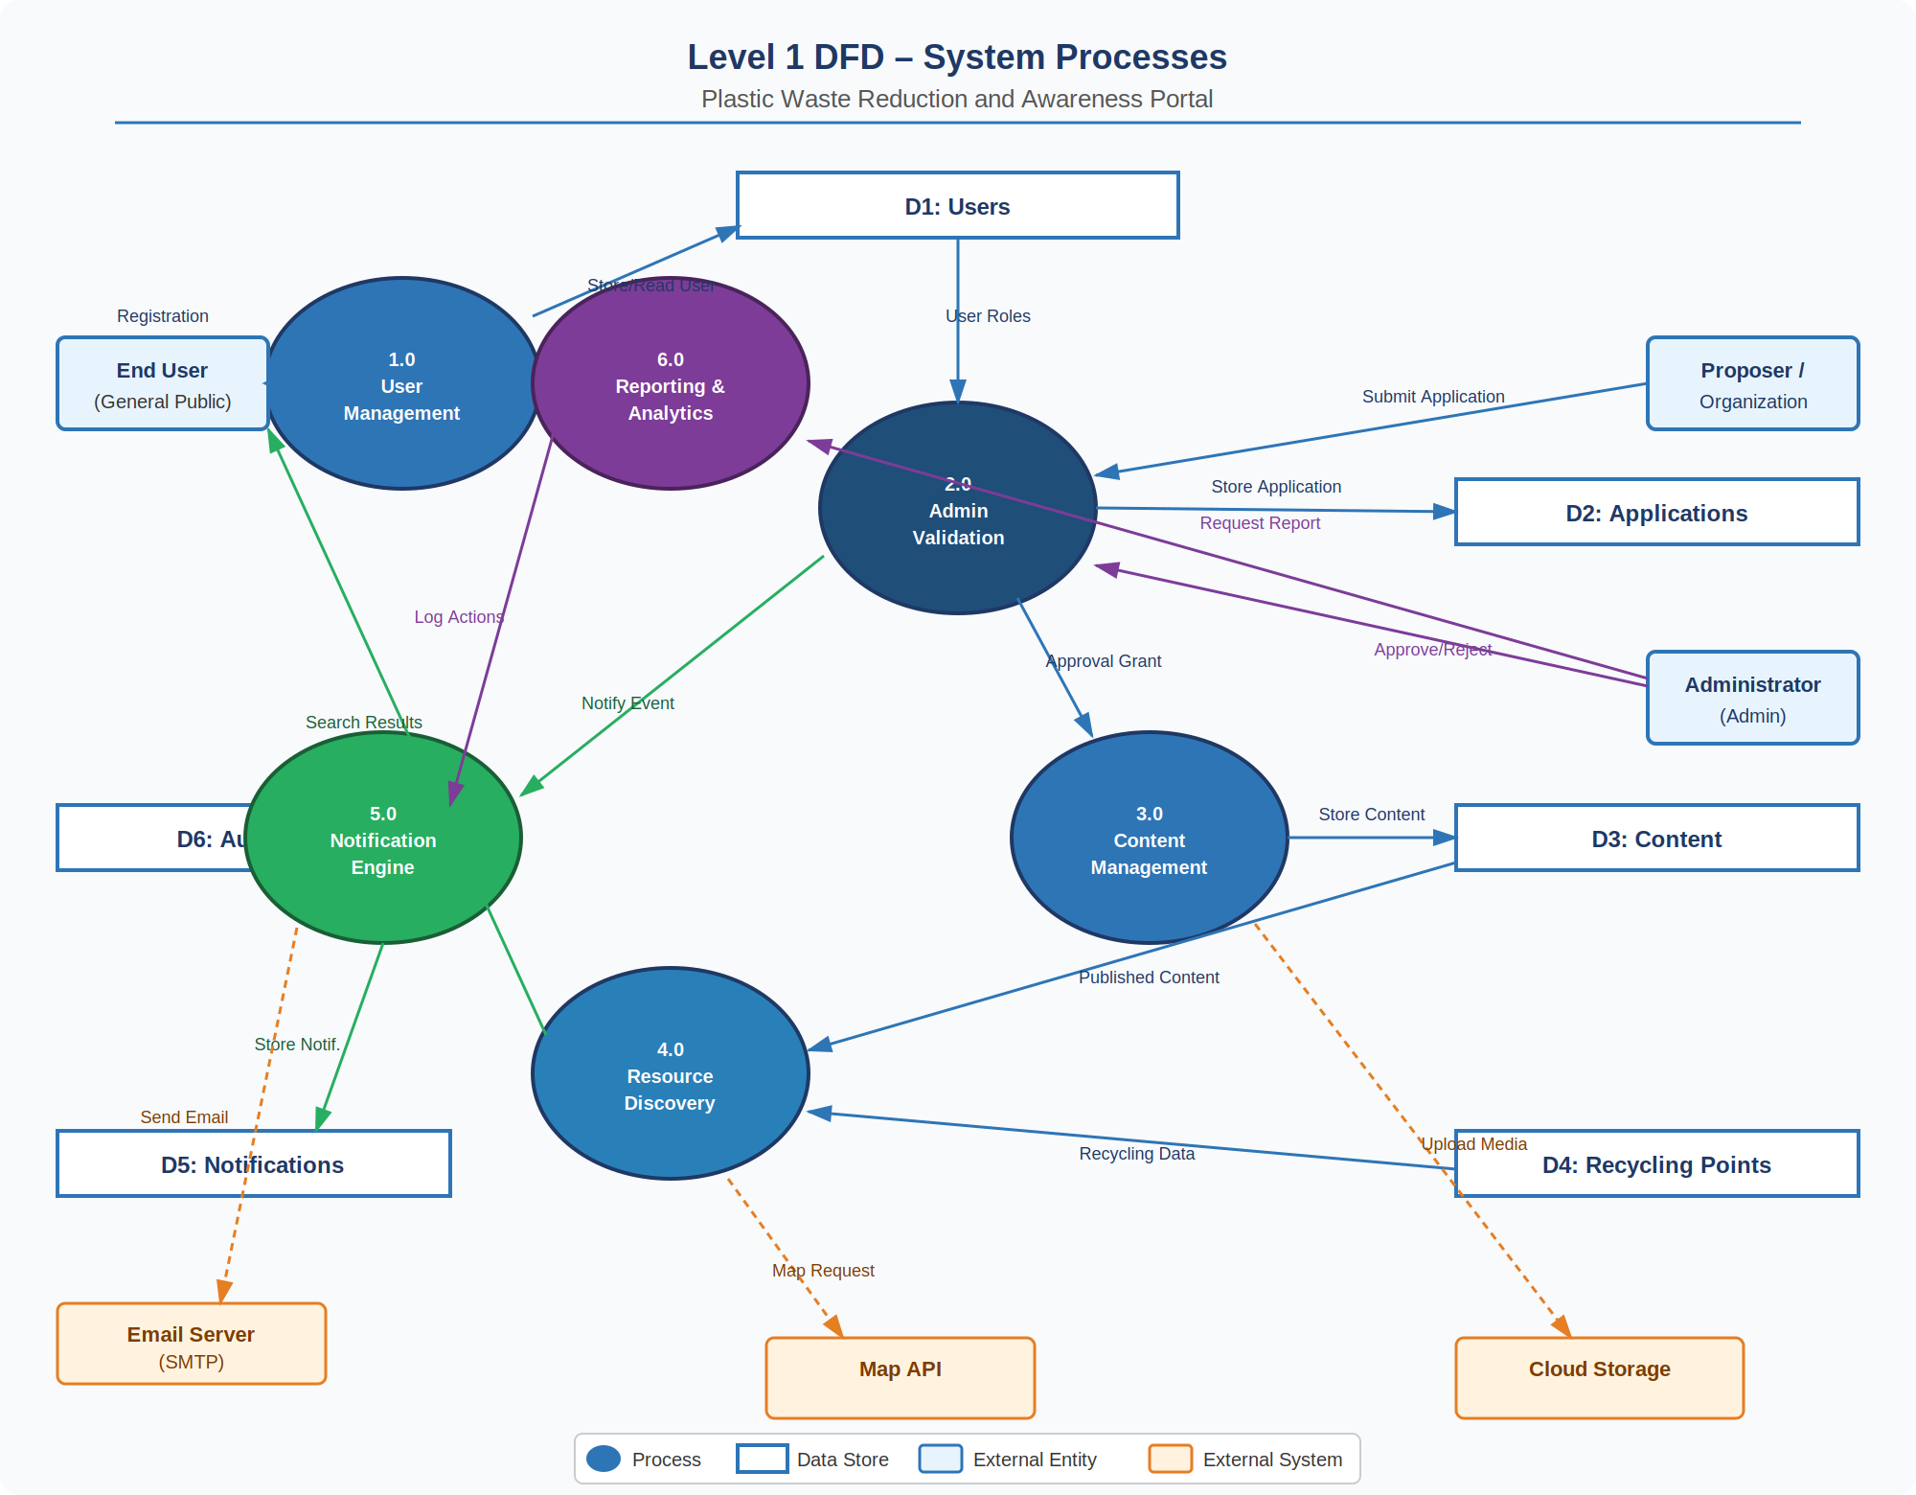
Figure 4.2 – Level 1 DFD (System Processes)

The Level 1 DFD shows 6 core processes: (1) User Management – handles registration and authentication; (2) Admin Validation – reviews and approves proposer applications; (3) Content Management – manages campaigns and resources; (4) Resource Discovery – processes end-user search queries; (5) Notification Engine – dispatches email and in-app alerts; (6) Reporting & Analytics – generates usage and campaign reports for administrators.

5. Github Link
[Insert GitHub Repository Link Here]

6. Deployed Link
[Insert Deployed Application Link Here]

A. Appendices
Appendices provide supplementary information to support the SRS. The content within these appendices is considered part of the overall requirements set.

A.1 Appendix 1 – Use Case Diagrams
The following use case diagrams illustrate the interactions between actors and the Plastic Waste Reduction and Awareness Portal system. Actors include End Users, Proposers/Organizations, Administrators, Recycling Agencies, and external systems. Relationships are shown using association lines, with <<include>> indicating mandatory sub-use cases and <<extend>> indicating optional or conditional ones.

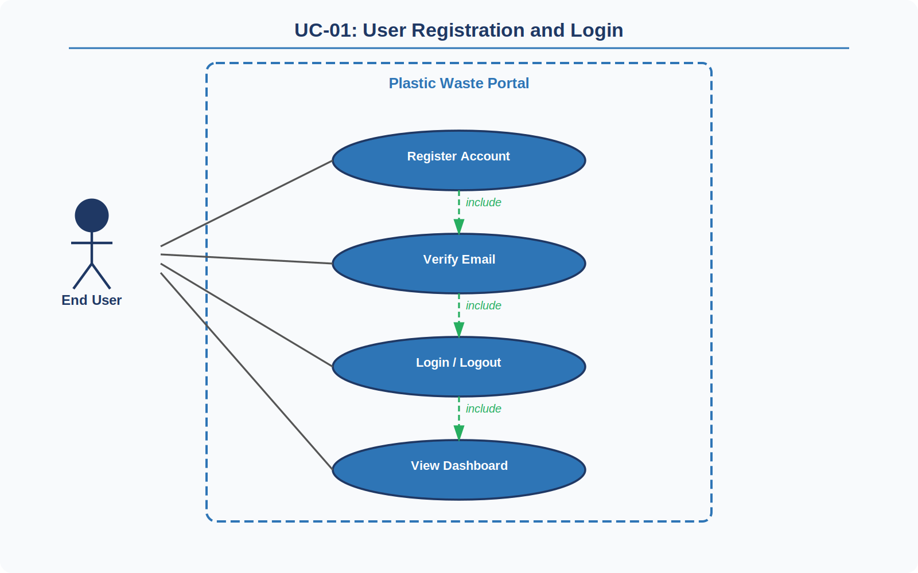
Figure A.1 – UC-01: User Registration and Login
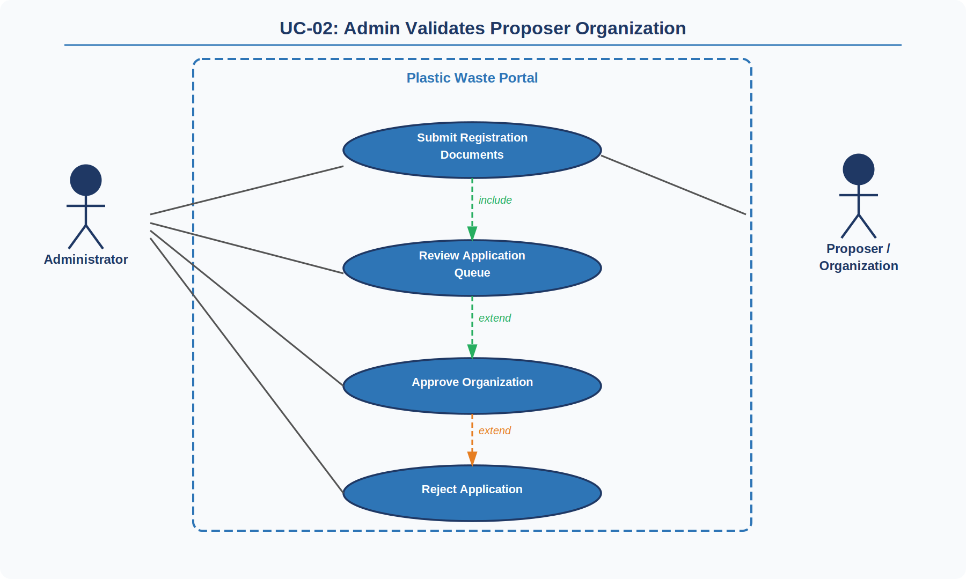
Figure A.2 – UC-02: Admin Validates Proposer Organization
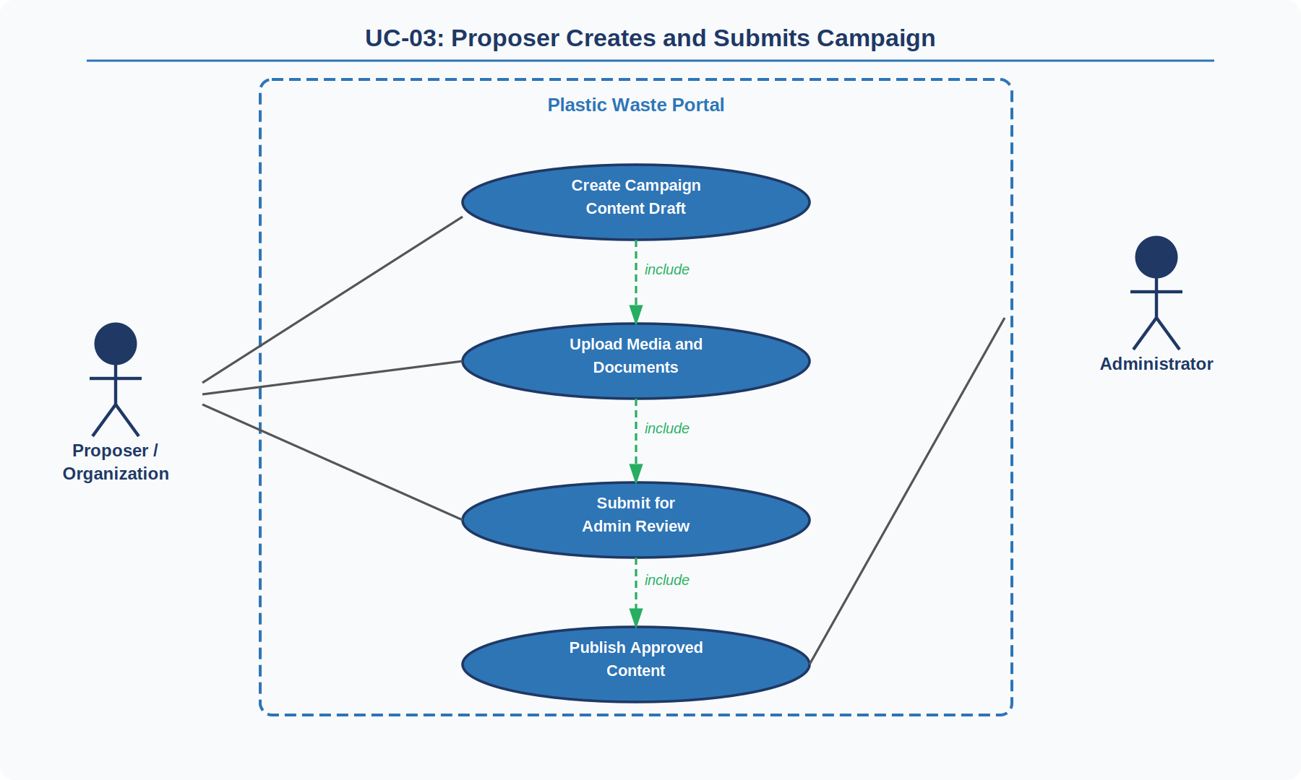
Figure A.3 – UC-03: Proposer Creates and Submits Campaign
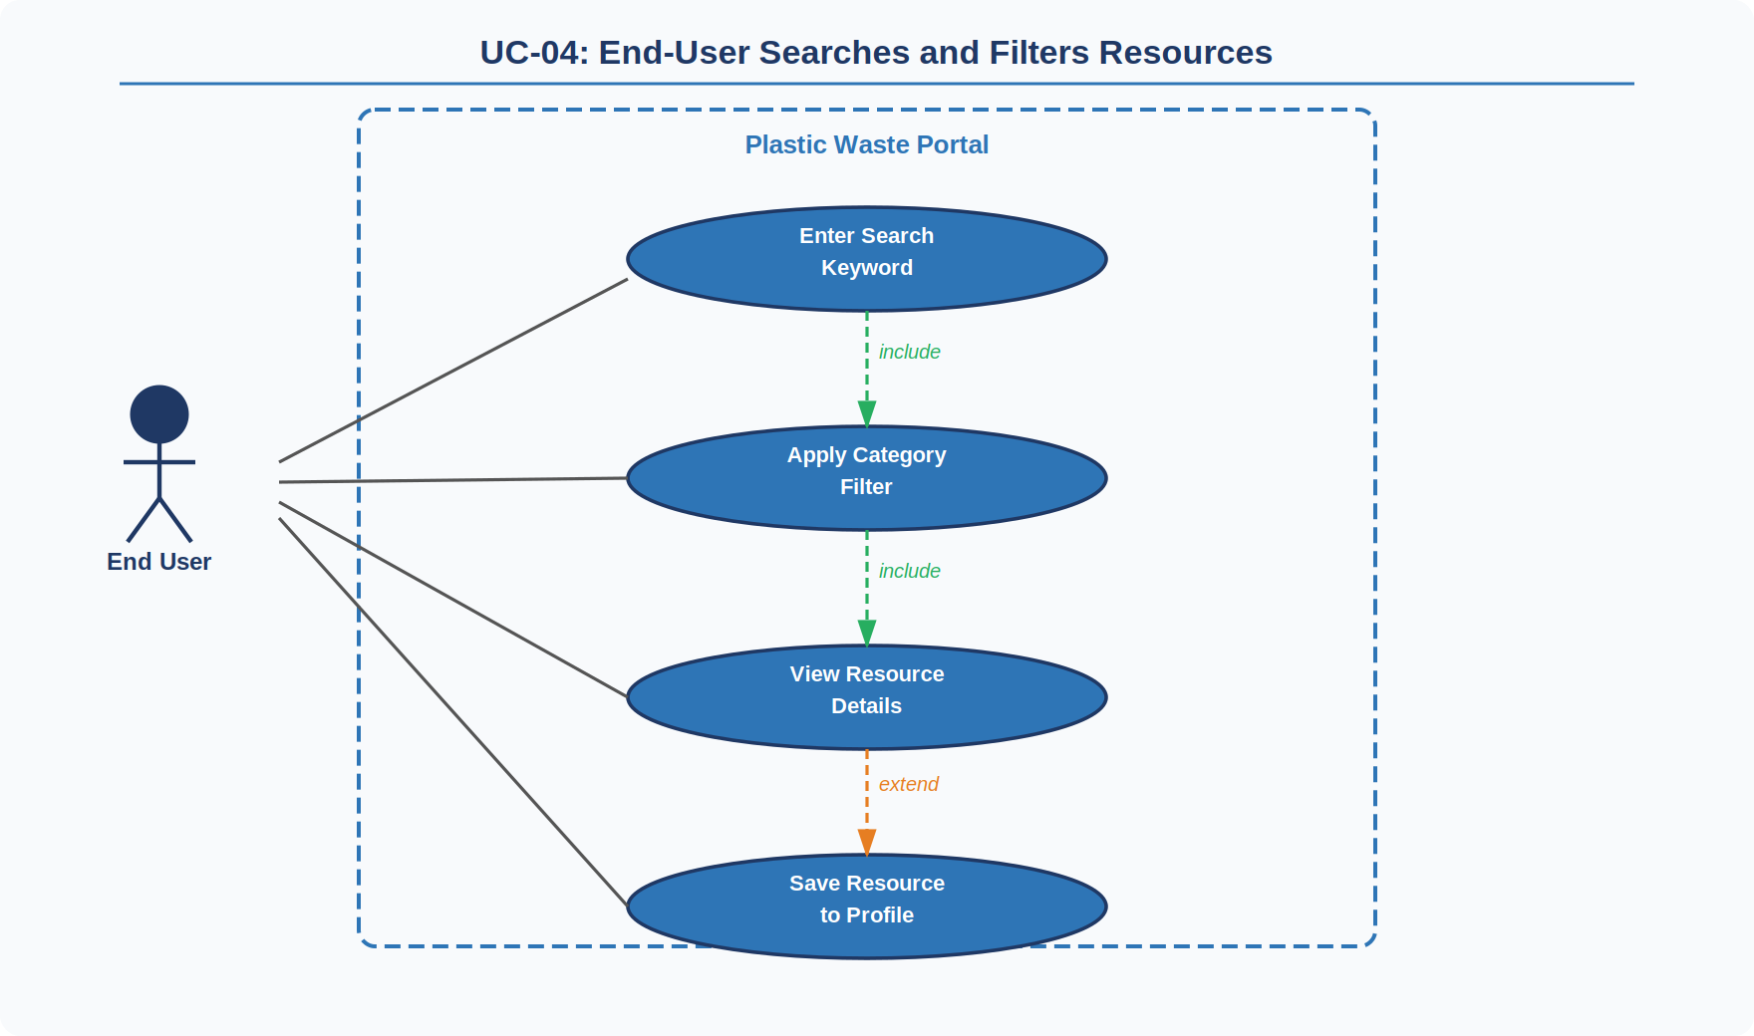
Figure A.4 – UC-04: End-User Searches and Filters Resources
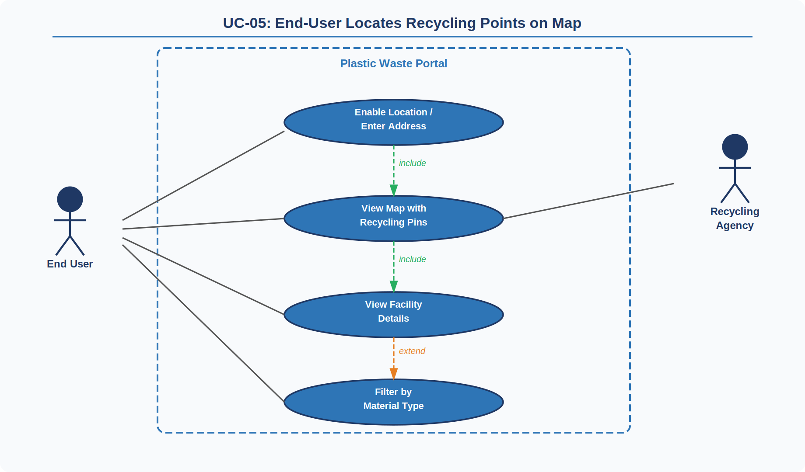
Figure A.5 – UC-05: End-User Locates Recycling Points on Map
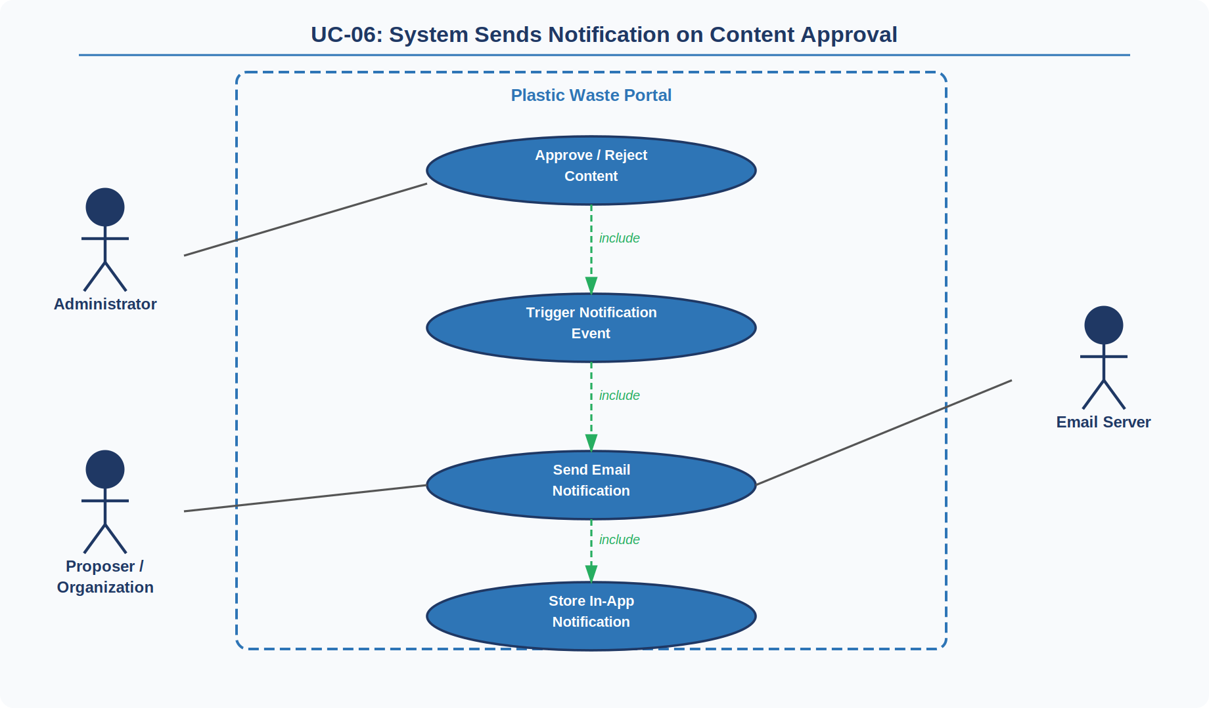
Figure A.6 – UC-06: System Sends Notification on Content Approval
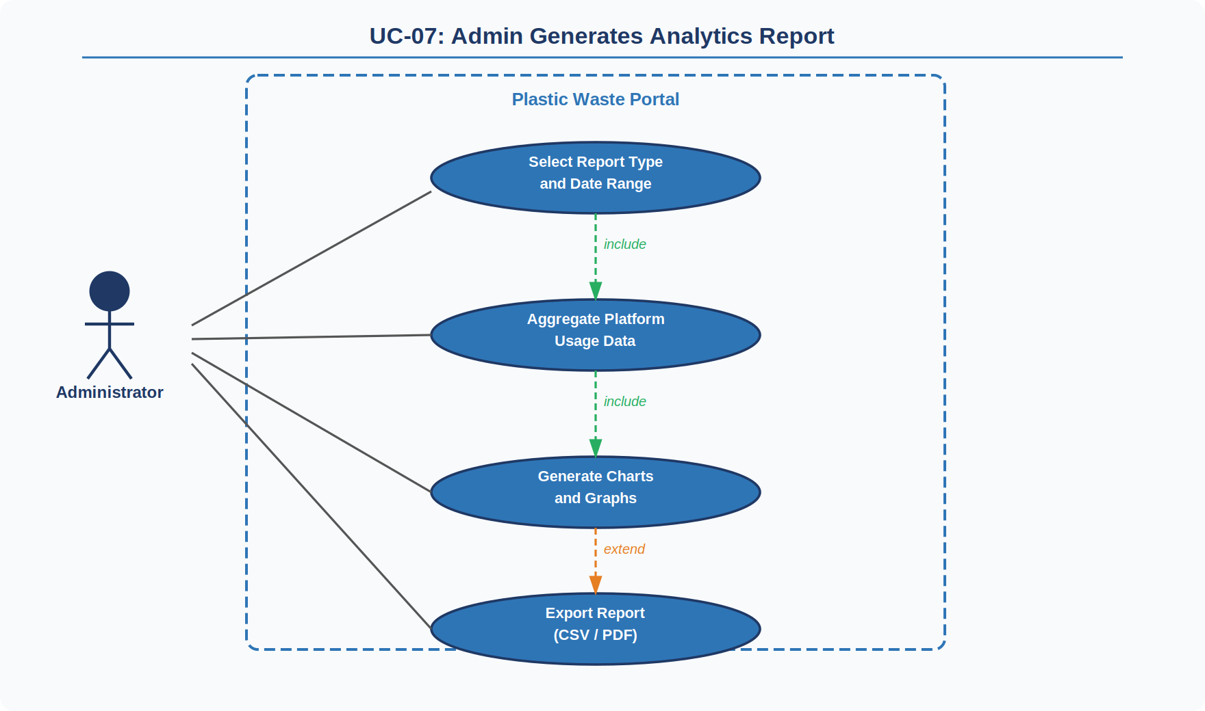
Figure A.7 – UC-07: Admin Generates Analytics Report

A.2 Appendix 2 – Entity Relationship Diagram (ERD)
The ERD for the Plastic Waste Reduction and Awareness Portal includes the following primary entities and relationships:
- User (UserID, Name, Email, PasswordHash, Role, Status, CreatedAt)
- Organization (OrgID, UserID, OrgName, CertificateURL, Status, ApprovedBy, ApprovedAt)
- Content (ContentID, OrgID, Title, Description, CategoryID, MediaURL, Status, PublishedAt)
- Category (CategoryID, CategoryName, Description)
- RecyclingPoint (PointID, OrgID, Name, Address, Latitude, Longitude, MaterialTypes, OperatingHours)
- Campaign (CampaignID, OrgID, Title, Goal, StartDate, EndDate, Status)
- Notification (NotifID, UserID, Message, Type, IsRead, CreatedAt)
- AuditLog (LogID, AdminID, Action, TargetID, Timestamp)

